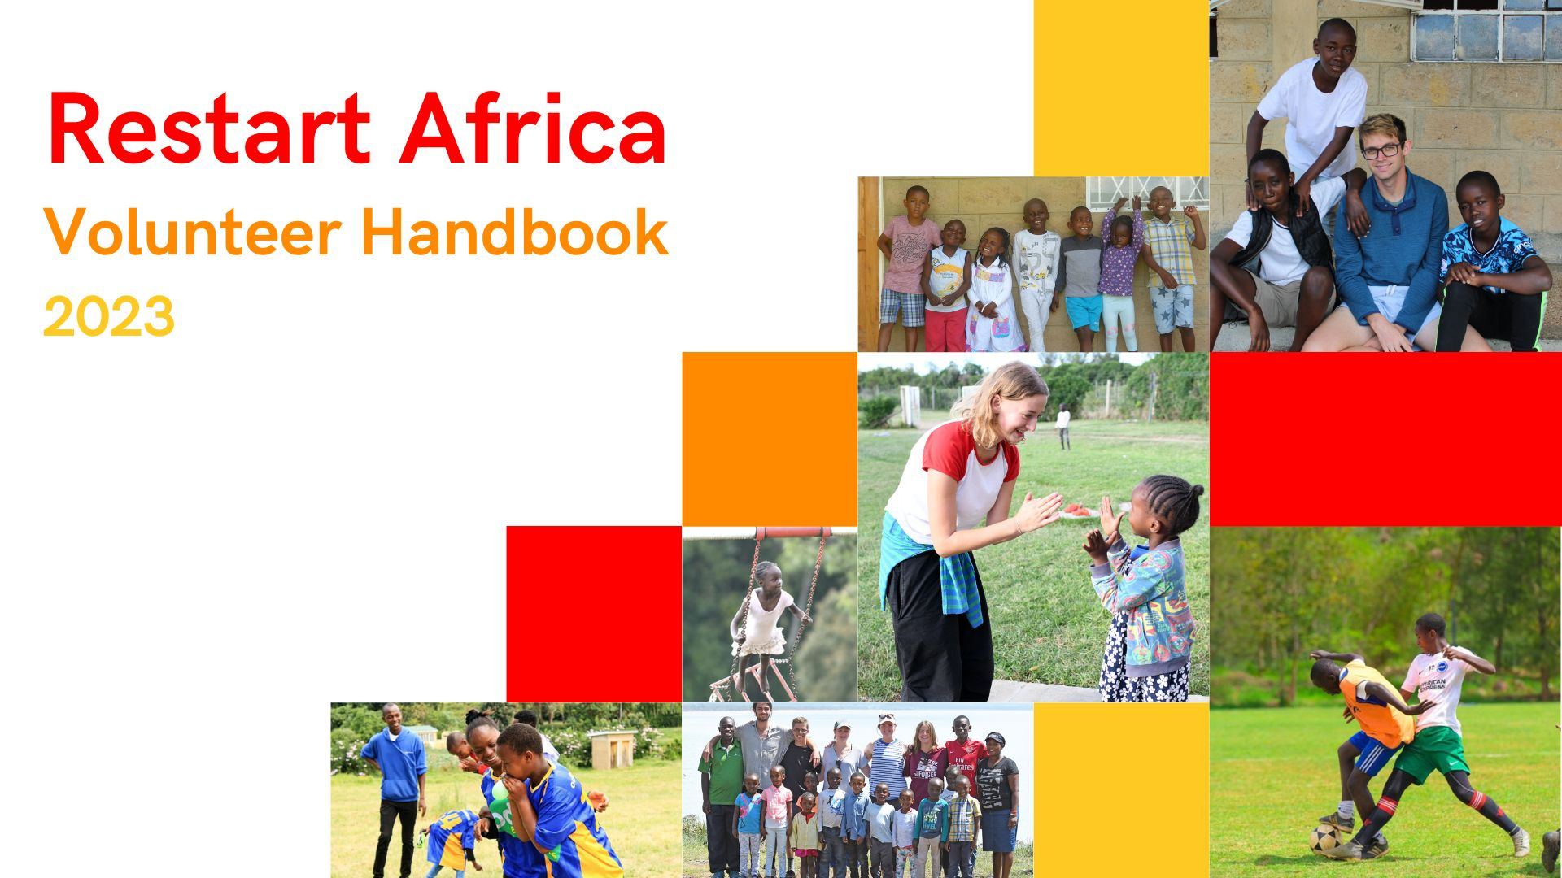
Volunteer Handbook, 2024
Written by volunteers, for volunteers

“The children will teach you more than you ever thought possible. They will teach your heart to love, your perspective to grow, and your imagination to run wild. Come to Restart, not only to teach, but to learn.” Kati Kelsey, volunteered in 2011, 2012 & 2015.

Contents

WELCOME 3
HISTORY OF RESTART AFRICA 4
POINTS OF CONTACT 5
OVERVIEW OF THE VOLUNTEER PROGRAM 6
VOLUNTEER PROGRAMME AND ACTIVITIES 10
DAY TO DAY ISSUES 11
SECURITY AND SAFETY 13
HEALTH 14
SAFEGUARDING 15
NEARBY PLACES TO VISIT ON A DAY OFF 15
EXPLORING KENYA? 17
DONATIONS 18
RESTART SOUVENIRS 18
AT THE END OF YOUR STAY 19
IMPORTANT 19
FURTHER INFORMATION 20

WELCOME

First of all, welcome to Restart Africa. We hope your experience with us is insightful, and educational but, most importantly, fun.

This handbook is intended to provide additional information to answer questions and concerns you and your family may have. It will touch on the following:

- The History of Restart
- The Overview of the Volunteer Program
- Health, Security and Safeguarding
- Day to Day and Travel

Within the handbook, you will read various testimonies from previous Restart volunteers, sharing some of their favourite moments and pieces of advice.

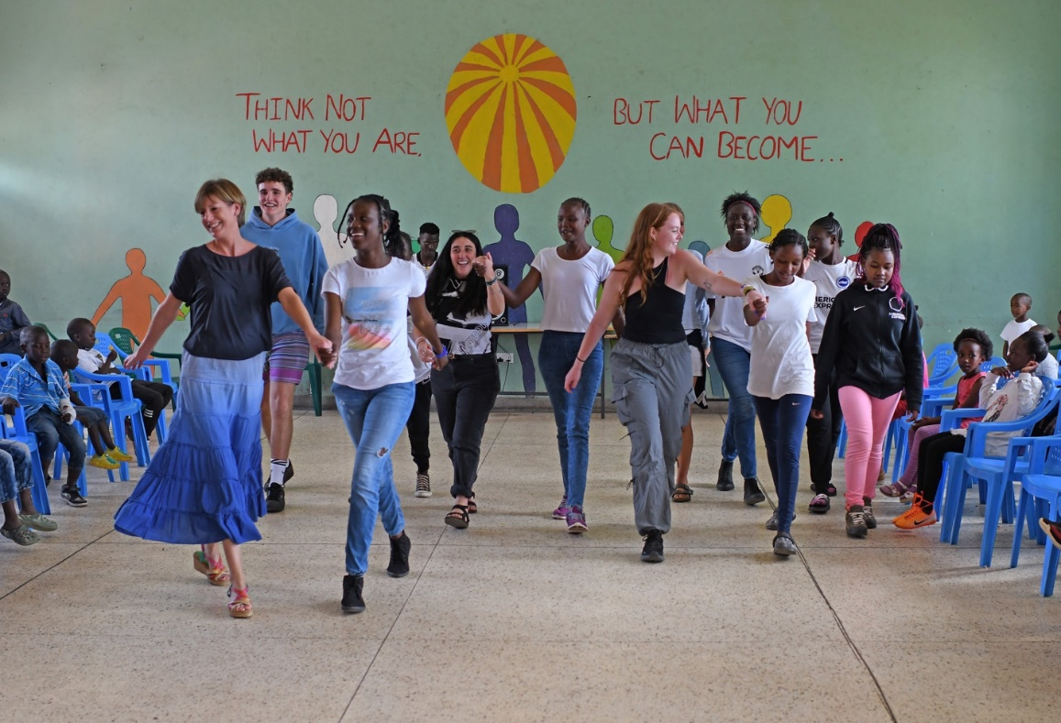

“A highlight of going to Restart for me was seeing, feeling, and experiencing the power of love. Seeing a new kid’s growth at Restart, over just a couple of weeks, as he went from silent, scared, and hopeless to smiling, laughing, and loving his new family, was one of the most amazing experiences of my life.” - Jess Lyon, volunteered in 2022

HISTORY OF RESTART AFRICA

Restart Africa was founded by Mary Coulson in 2007. Following Kenya’s general election in 2007, Mary noticed a concerning increase in the number of homeless children throughout the streets of Gilgil and felt a call to help. Mary knew that these children were at a high risk of starvation, violence, drugs, and sexual abuse. In 2007, Mary opened the first Restart Centre in the town of Gilgil. The Centre was a modest rental property and it provided refuge to 6 boys. Over the years, the number of children in the care of Restart grew to over 100. In 2014, Restart moved to a beautiful new premise in Langalanga, which provides the children with shelter, food, education, love, and stability.

Alongside boys’ and girls’ dormitories and nursery, the new centre has classrooms, a fully stocked library, a dining hall, a music room, and laundry facilities. The new centre also includes a large sports field, playground, and Restart’s own agriculture project. The agriculture project provides the children with fresh and organic vegetables daily and allows them to have little “shambas' (farm) where they learn how to grow flowers and vegetables independently.

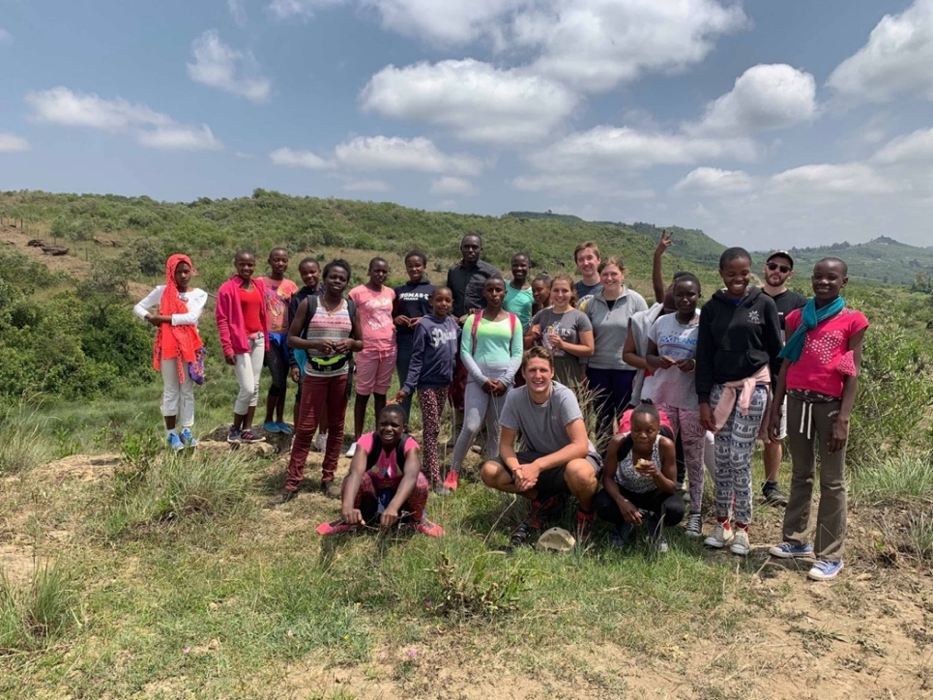

“Pat and I were doing craft work with a number of young ones when Mary and the British High Commissioner came by and found us all singing “There’s a Hole in my Bucket Dear Liza” It’s a lovely memory”. – Margaret Butler, volunteered in 2019.

POINTS OF CONTACT
- Founder and Executive Director
Mary Coulson MBE is the Founder and Executive Director of Restart Africa. Mary oversees and is responsible for all matters at Restart Africa.
Contact Mrs Mary Coulson: +254 723 786008

- Volunteer Coordinator
Abdi is responsible for the volunteer program at Restart. He is the first point of contact throughout your stay.
Contact Abdi: + 254 724 397225 / Email: volunteer@restartafrica.org
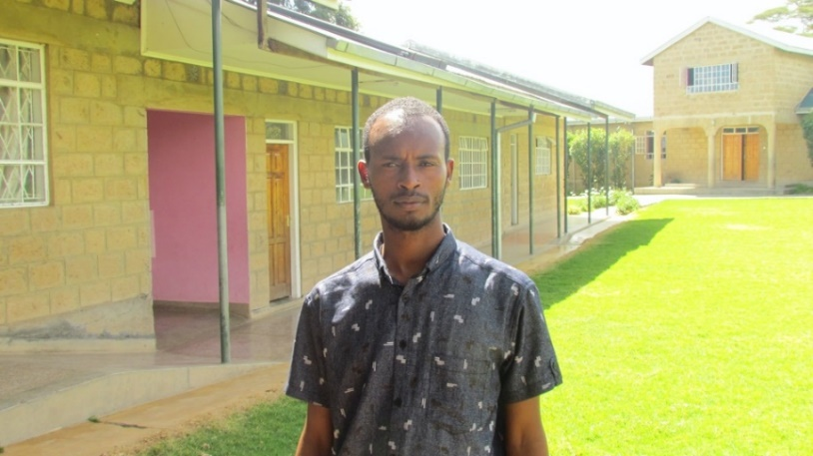

Please let Mary or Abdi know if you have any questions, concerns, or need any supplies while you are at Restart. If you wish to know more about the staff, please visit the website where you will find a list of key staff and their role. Don’t be afraid to say hi.

Details of other staff are available on the Restart website.

OVERVIEW OF THE VOLUNTEER PROGRAM
Where it all began …

In 2009, Restart welcomed its first volunteer and has since hosted over 100 volunteers, many of whom visit year after year. Volunteers have had an everlasting impact on the children at Restart, helping them to expand their view of life, giving them hope for the future, developing their ambitions and talking about their future education and training. Restart has had a profound impact on volunteers as well. It may help you shift your life perspective and teach you things you never knew about yourself.

Arriving in Kenya and Restart

Upon arrival, you will be picked up by Restart’s highly trusted taxi driver, Kim. Kim has safely transported volunteers to and from Restart for over a decade and may treat you to your first Kenyan breakfast if you arrive in the morning. He is a big fan of his chai!

Kim’s number: +254 727 316094

There are designated volunteer flats (apartments) located within the compound. The flats are:
- located near the shambas (veggie patch) and sports field, just a small distance from the main buildings, giving volunteers the space to decompress and socialize.
- equipped with a bedroom and bunk beds, living area, small kitchen, and a toilet, with a shower that (usually) has hot water. Each flat can accommodate two people in the bunk beds so volunteers should be prepared to share a flat with another volunteer, if the need arises.
- set up with a variety of furniture and kitchen supplies, such as fridges, hot plates, a kettle, and sofas.
- connected to Wi-Fi, which is sometimes patchy. Please ask the Volunteer Coordinator for the password.
- supplied with a communal gas cooker, shared utensils, microwave and kettle. Although volunteers are encouraged to dine with the Restart family, you may prepare simple meals at your own expense.

Note: It is your responsibility to keep the flats clean and the small garden area tidy.

If you arrive at the centre during the day, you will be met by a staff member who will help you get settled into your flat. If you arrive during the night, your flat will be prepared so you can get a good night's sleep. On your first day, you will be given a tour of the compound and will meet with the Volunteer Coordinator to ensure that you have all the supplies you need.
Your first couple of days can be a little overwhelming as you adjust, but do not worry. The staff and children are very welcoming and will make you feel at home right away.

While it is not guaranteed there will be other volunteers there during your stay, Restart works hard to try to have at least 4 volunteers at a time. If at any time you have questions or concerns, please let the Volunteer Coordinator know. Everyone at Restart will help to ensure that you have the best possible experience.

It is expected that you will eat meals with the children, but you can also cook for yourself.
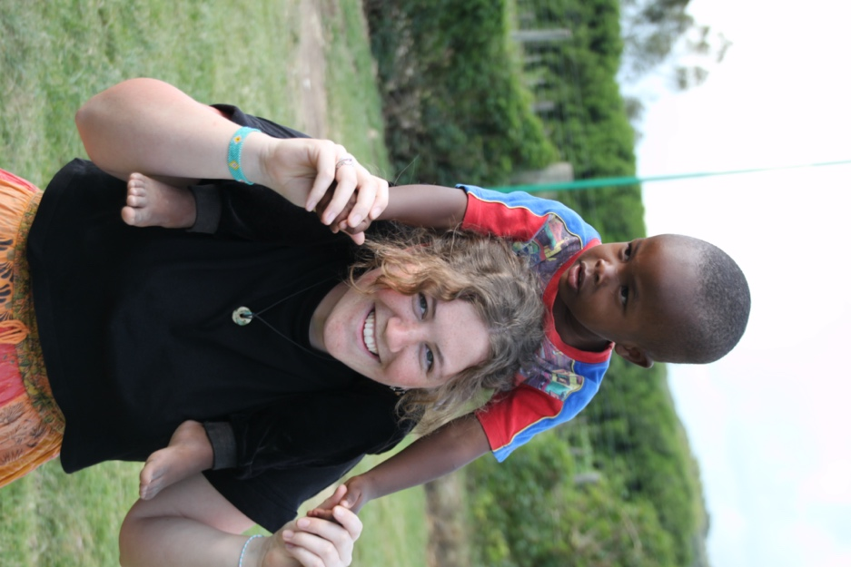

Once you’re settled …

One of the best parts about being a volunteer with Restart is that no day is the same. One day you’ll be spending hours preparing lunch with the older children, and other days you will be chasing the nursery kids around the sports field. You will certainly learn something new each day, whether that’s a new card game, dance move, or word in Swahili. The children are always eager to teach new volunteers.

As a volunteer at Restart, you will act in a supportive role, whether that is assisting the children with schoolwork, playing on the field, or helping in the kitchen. Depending on which time of year you are at the centre will depend on your schedule.

- Holiday periods: your days will be busy spending time with the children.
- School Term: you might go to school with the younger children, work in the shambas or assist the Restart staff as required.
- Please do not be afraid to share your hobbies and talents with the children, they love to learn, especially from our volunteers.
- Voluteers may take groups of children on day trips to local places of interest, so long as correct staffing requirements are adhered to and proper planning has taken place. Any proposals must be discussed with the Volunteer Coordinator and the Restart Manager. Any costs will usually be covered by the person planning the trip. Please ask for suggestions, but Mt Longonot, Lake Elementaita and Crescent Island on Lake Naivasha are popular.
- If you are bringing certain skills with you such as music, sports, teaching etc., let the Volunteer Coordinator and Mary know and they will try to find ways to have you utilize your skills. Even better, before you leave home give some thought to how you can contribute while you are here and what materials, if any, you may find it useful to bring. It is likely that the more prepared you are, the more rewarding your experience will be. Some examples of activities that past volunteers have implemented successfully are as follows:

- arts and crafts - the younger children love to colour
- talent shows
- yoga in the sports field
- morning runs
- volunteers cook dinner night / bake cookies
- sports tournaments
- a reading club
In accordance with the ideals of volunteer service, you should seek no financial benefit while bringing your knowledge, abilities and experience to the charity. Volunteers must not undertake paid work or engage in business activities while volunteering.

You may also meet regularly, and mostly informally, with the Volunteer Coordinator to work out what else you can do. Remember to use these opportunities to advise if you are running low on supplies (toilet paper, water, etc.), so that these can be replenished.

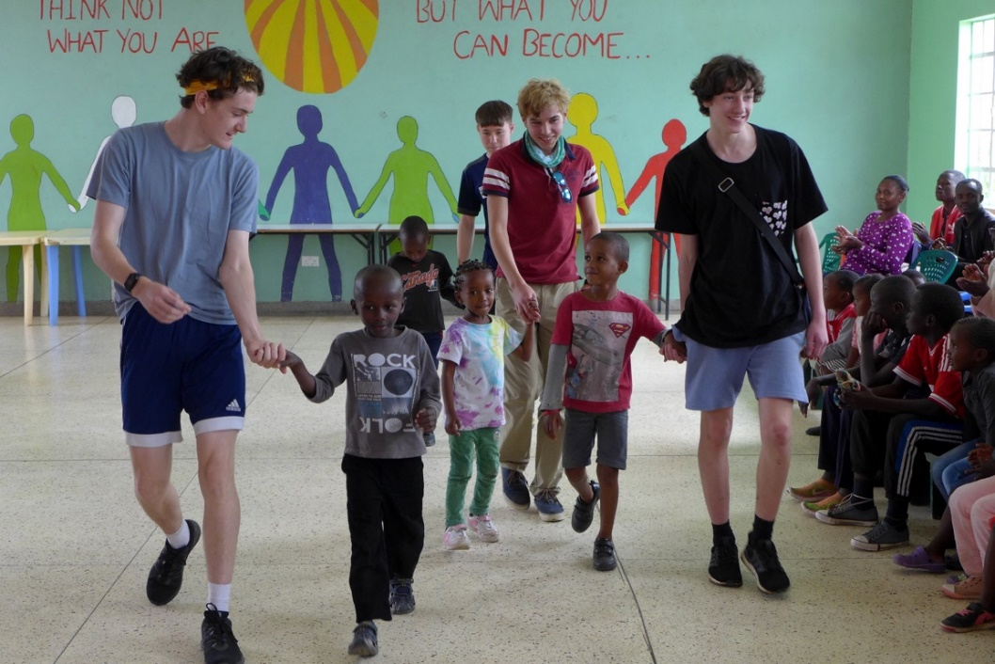
Each week you can have one day off, ideally a weekday, where you can explore the surrounding areas, eat some delicious food, and get to know the volunteers. Later in the handbook, you’ll find a recommended list of places to visit on your day off.

VOLUNTEER PROGRAMME AND ACTIVITIES
During your time with us, you will be involved in various activities aimed at supporting the children and the community. Below are some examples of the types of activities that you may get involved in. Restart is a busy place, so some of the events may not happen exactly as described.
- School visits: Twice a week, volunteers may visit the local schools that the Restart children attend, to engage with students and support educational activities.
- Colouring club: Join our weekly colouring club sessions, held every Saturday, and more frequently during the holidays. This will enable you to engage with the children through creative activities.
- Organised sports events: Participate in organised sports events on Saturday afternoons, coordinated with house masters, to promote physical activity and teamwork.
- General cleaning: On Saturday mornings, assist with the weekly general cleaning of the centre, to maintain a clean and safe environment for all.
- Youth club: Once a week, engage with the children through various activities such as table tennis, art and craft, board games, and music and dancing, to name a few.
- Reading: Support children who may have reading difficulties, particularly during school holidays.
- Homework: Help children with their homework every afternoon from around 5 pm to 6 pm, to ensure they complete their assignments effectively, and on time. :
- Mealtimes: Join the children for supper every day at 6:15 pm and assist with clearing up after the meal.
- Kitchen assistance: Get involved in the kitchen once a week, to prepare food, clean, and interact with the kitchen team.
- Laundry assistance: Assist with laundry duties once a week, to ensure that the large amount of washing is done.
- Sunday activities: After church worship, usually held in the dining hall, children engage in various activities, often organised by volunteers, with approval from the centre manager and coordinator for activities, e.g. hiking. Choir, dance, art and craft sessions occur Sunday evenings, providing fun and encouragement. Volunteers should ensure children are not engaged past 9 pm without permission from boarding staff.
Note: Volunteers should not interfere with planned children’s programmes but complement them. They should also encourage children in their chores and responsibilities.

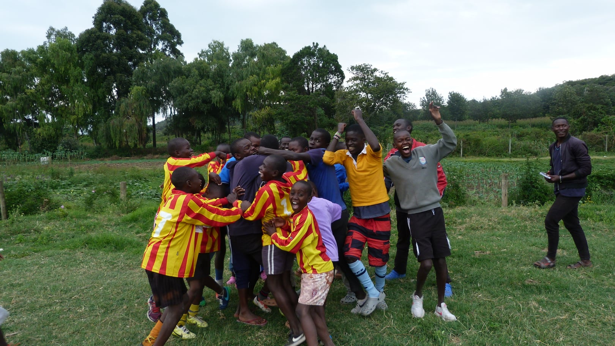

DAY TO DAY ISSUES

Clothing

Langalanga is generally either hot or warm, and in the rainy season, there is a often a short burst of rain in the afternoons.

When working with the children, you will only need casual and practical clothes. Do bring a fleece and light waterproof for the cooler days. Trainers are ideal footwear as you will often be walking along dusty (sometimes muddy) tracks. Flip flops and sandals are also a useful backup. It is also a good idea to include a simple set of relatively neat clothes for outings to restaurants or for when you are in Nairobi.

Banking, Phones and Data

You will be able to access ATMs in Gilgil. We recommend ABSA as it has the lowest transaction fees. If you will be in Kenya for a length of time, we would recommend getting:
- an M-PESA account, which is a secure, money transfer and payment system, exclusive to Kenya, and it makes paying through your phone very easy.
- a SIM card to allow for texting and calls.
Both the M-PESA and the SIM card are available through Safaricom, but if you arrive at Restart without them, don’t worry. The Volunteer Coordinator will help you set them up.
The international dialing code for Kenya is + 254.

Electricity

Kenya uses UK standard electric plug fittings. Power cuts in Kenya are frequent, so it is advisable to use a surge protector.

Home Comforts

As previously stated, you will be expected to eat with the kids often. However, we understand the need for home comforts.
Restart is located approximately 8 kilometres from Gilgil and it is easy to get into if you need extra supplies. Just ask the Volunteer Coordinator and / or phone Kim, the driver, to arrange transport. Chawakas and EastMatt are the main grocery stores in Gilgil. They are both well-stocked and have most things you will need for some home cooking, breakfast, tea, toiletries etc. You can also go to the local markets in Langalanga, these are not as well stocked as Gilgil but you will find your basic essentials (tea, milk, toothpaste) here and it is all within walking distance.

Laundry

Wednesday is laundry day. You may leave your clothes and bedding (except underwear) in the basket outside of your flat, where they will be collected, washed and returned, or hung up on the line. You must wash your underwear yourselves.
A housekeeper will visit every day and she will also do basic laundry once a week. Please treat your housekeeper with respect at all times

Getting your photos on social media

We are keen to get YOUR photos on Facebook and Instagram as you have a great perspective on day-to-day life with the kids. If you have any good photos from your days at Restart, particularly of any out-of-the-ordinary events, then please send them over to our Fundraising Coordinator, Ben, in the UK. He is a previous volunteer himself so he will be happy to hear your stories from Restart.

Ben’s Whatsapp No. is: +44 7925 181260, or email him at fundraising@restartafrica.org

Going Off Site:

When you are planning to go off-site, it is important that you let the Volunteer Coordinator know your plans. Please do not visit local bars and nightclubs without getting advice first.

Getting around:

Boda Bodas (motorbike taxis) are a common form of transport in Kenya. If you decide to take a boda boda into Gilgil, it is ideal to wear a helmet. Restart have a couple that you can borrow. Try to choose your boda drivers wisely, or Restart have some preferred riders that you can contact, but only before 7 pm. DO NOT get a Boda Boda on the main roads outside of Gilgil, only get the taxi.

You can also contact our taxi driver, Kim, and he can take you further afield.

SECURITY AND SAFETY
Health and safety are a top priority for all staff, volunteers and children at Restart:

- The entire compound is safely secured with an electric fence and is patrolled 24/7 by a team of “askaris” (guards).
- All the flats have a lock and key and it is strongly recommended that you lock your door when you leave, and at night. The staff and children do not generally go down to the volunteers' flats, unless to clean them, but it is still good practice to keep money, valuables (and sweets) secured when you leave your room.
- It is prudent to be mindful of your belongings (ipads, phones, wallets, money, laptops), be it at the apartment or anywhere else. Do not leave them lying around at they are easy to pick up and may be a simple temptation to people who are less well off.
- There is a safe in the office, where you can keep your passport, or other items of value, should you wish.
- The locals in Langalanga and Gilgil are very friendly to westerners, so smile and be friendly. However, avoid being drawn into conversations if you feel uncomfortable. Do not give money, if asked, and avoid anyone who is obviously under the influence of alcohol.
- For your safety and that of others, you must not bring strangers to the apartments. If you wish to invite a friend to visit Restart, please request permission from the Restart Manager.

HEALTH

- It is advisable to wash hands regularly. Use hand gel too.
- You will be provided with clean, filtered water to drink during your stay. ONLY drink bottled water, when traveling outside of the centre, unless you are 100% sure the alternative is safe.
- The centre is located at approximately 1,981 meters (6,500 feet) above sea level. As a result of the high elevation, you should ensure you hydrate well before arriving and throughout your stay at Restart. You may experience headaches for the first couple of days, particularly if you are from a low-lying area.
- Due to the high altitude, Restart is not a malaria zone. Therefore, antimalaria medication is not required. There are still plenty of mosquitoes around, especially at night, so it's recommended you use the supplied bug net and bug repellent.
- If you plan to travel throughout the rest of Kenya, you should consult with your doctor about taking antimalarial medication.
- Restart is equipped with multiple basic first aid kits. If at any point you require one, please ask the Volunteer Coordinator or another staff member.
- Bosma Chemist, in Gilgil, has a selection of common over-the-counter medication and basic medical supplies.
- If you are witness to an accident, override the instinct to stop and help. The situation may become volatile, but if you accompany the person to hospital, you might be expected to pay the medical bills and the police may also make accusations.
- Female volunteers should bring adequate supplies of personal hygiene for their stay. Whilst most products are available in Gilgil, choice and supply cannot always be guaranteed and products may be expensive. All female sanitary items should be disposed of in the long drop bin at the end of the Restart farm.
- Avoid contact with local dogs.
- Although snakes are present, it is unlikely that you will see them. However, avoid walking barefoot, especially at night. If bitten, seek immediate medical assistance.
- You should be aware that HIV Aids is an issue all over Kenya.

If you require additional medical care, please speak with the Volunteer Coordinator, or Mary, who will be able to help.

SAFEGUARDING

Restart Africa is committed to safeguarding. All staff and volunteers are expected to conduct themselves in a professional and appropriate manner whenever dealing with children. You must familiarise yourself with our Child Protection and Health & Safety Policies and abide by them at all time. The points below cover some. areas to consider when dealing with Restart children.

- Listen and support the children.
- Be fully aware of your position of trust.
- Maintain appropriate professional boundaries and do not display any behaviour that may be misinterpreted by others.
- Avoid all inappropriate physical contact or behaviour with the children.
- Avoid or minimise occasions when you are alone or in a secluded area with a child or children.
- Your conduct must reflect the charity’s respect for human rights, social justice, human dignity and the equal rights of men and women, regardless of race, gender, religion, colour, national or ethnic origin, language, sexual orientation, age, socio-economic status or political conviction. Any form of discrimination or harassment, including requests for sexual favours and physical or verbal abuse of others will not be tolerated.
- You must not under any circumstances engage in sexual relationships within the local community or with Restart staff.

Furthermore, do not allow the children to access to the internet via your own devices without supervision.

NEARBY PLACES TO VISIT ON A DAY OFF

Volunteers are expected / encouraged to work 6 days a week, although this may depend on the weekly commitments at the Restart Centre. If you want to arrange a longer trip of your own, during your stay, please discuss this with the Volunteer Coordinator.

When planning to go off-site, it is very important that all volunteers keep the relevant staff updated. Please inform the Restart Manager and the Volunteer Coordinator. Please DO NOT visit local bars, restaurants and nightclubs. Do not use unauthorised taxis or boda boda (motorcycle) riders. This is all for your own safety and security.

Local Farm Shop – 1 km beyond Pembroke House School on the Nyahururu Road. It provides a good selection of foods and snacks.

Pembroke House School Café – This is a nice place to relax. You can buy decent coffee, cakes and savories, and there is internet.

Gilgil Country Club - During your time at Restart, you may be invited to visit the Gilgil Club by gap students at Pembroke House School. Please seek advice from Mary before going, it is not a cash bar, so we need to book you in ahead of time. Volunteers will not walk to and from the Gilgil Club at night.

Hells Gate National Park provides the only bicycle safari experience in Africa. It will give you the opportunity to hop on a mountain bike (provided by the park) and see Africa’s great animals close up. It is about one hour drive from Restart.
Visit: www.kws.go.ke/content/hells-gate-national-park

Camp Carnelleys is a laid back, campground with a delicious restaurant located beside Lake Naivasha, about an hour’s drive from Restart. You can organise a boat trip from here to view hippo.
Visit: www.campcarnelleys.com

Crescent Island is located on Lake Naivasha and can only be accessed by boat. It is a wonderful place to spend the afternoon. You can walk across the island and see zebra, giraffes, and hippos.
Visit: www.crescentisland.co

Lake Elementaita Wildlife Sanctuary is about 35 minutes drive from Restart. Hiking is available on several hills and along the lakeshore and there are hot springs.
Visit: Lake Elementaita Wildlife Sanctuary (LEWS) | Kenya Wildlife Service (kws.go.ke)

Mt Longonot is a stratovolcano and a great place to go hiking. The hike is challenging, but worth it, and is located approximately two hours from Restart.
Visit: http://kws.go.ke/content/mount-longonot-national-park

Thomsons Falls is located on the edge of the Aberdare range. It is an amazing nature experience and has some lovely local restaurants where you can have tea or lunch. The falls are located approximately 1.5 hours from Restart.

“Make sure to explore the local area! Gilgil itself is beautiful so don’t be afraid to go for a walk in to town and go up the local hill behind Restart. There is an amazing viewpoint that looks out over the rift valley and you can see for miles. Turn left when you reach the end of the Restart track and just keep going up until you reach rocks!” – Bela Jones, volunteered in 2019 & 2023!

EXPLORING KENYA?

If you are here for a long stay, or are looking to travel after your stay, then Kenya is alive with amazing experiences and places to visit. Whether your thing is being on safari, hiking up some of the world’s highest mountains, or relaxing by the coast, Kenya has it all. We suggest that you seek Mary’s opinion on where the best spots are.

DONATIONS

Many volunteers like to bring donations / gifts from home. They are very welcome, and a well-chosen gift can be extremely useful or great fun for the kids. The following items are always in high demand:

- sneakers / shoes
- school supplies, such as stationery, marker pens, felt pens, coloured pencils, colouring books etc.
- unused underwear
- sports equipment,
- children to adult-sized clothing

If you are not sure what to bring then please email the Volunteer Coordinator. Please pass any gifts to the Volunteer Coordinator on arrival and they will be logged and distributed. Usually the donations is distributed according to need. However, if you wish to use the funds for a specific project or for a particular group of children, please discuss this with Mary.

Finally, we are only making the above comments to be helpful. There are no expectations to bring anything, just yourself and your enthusiasm.

RESTART SOUVENIRS

The Sanata Women’s Groups is an on-site clothing group that makes belts, sandals, bracelets, bags and more. If you would like a hand-made souvenir from your time at Restart, then don’t be afraid to head to their room and have a browse. All their products are hand-made, and all income goes directly to Restart.

AT THE END OF YOUR STAY

Before you leave Restart, you will undergo an exit interview with the Volunteer Coordinator. This will give you the opportunity to provide feedback on your experience and to suggest areas of improvement.

Upon completion of your time at Restart, you will receive a Volunteer Participation Certificate. A recommendation letter may also be provided upon request.

IMPORTANT

- Volunteers are role models to the children at Restart. It is important you set an example both inside and outside the charity.
- You are expected to always be presentable and dress appropriately. Clothing should not be overly revealing. In our relatively conservative community, unusual hairstyles, or facial hair is discouraged and extra piercings and tattoos should be discreet.
- Volunteers shall not smoke, be in the care of children while under the influence of alcohol, or provide any child with illegal substances or alcohol.
- Volunteers shall not under any circumstances buy and/or consume any drugs. If you do, you will be asked to leave immediately.
- If you have any concerns about the welfare of a child, or their behavior, please speak with the House Mother or House Master.
- If you have any concerns and would like to report a staff member, please speak with a member of the Senior Management Team.
- The management of Restart Africa reserves the right to terminate any volunteer’s stay at Restart.

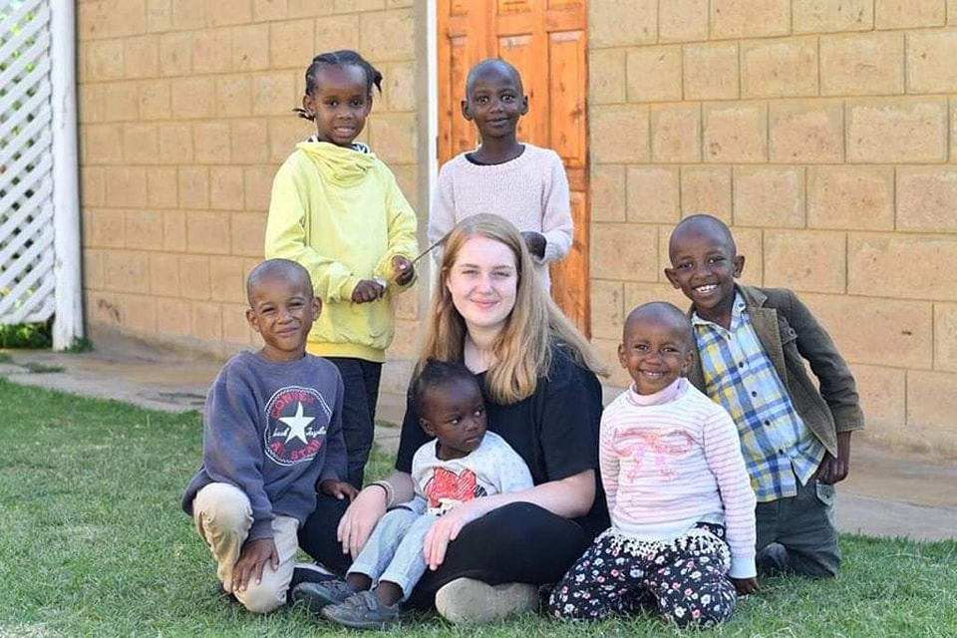
Lastly, enjoy your stay at Restart Africa. Have fun, learn lots and make sure to have the time of your life. We can promise you now, once you have been to Restart you will find it hard to stay away…

Still haven’t heard enough?

If you have any questions for some previous volunteers, Ben and Bela would be happy to receive an email. Bela’s email is belaj103@gmail.com and she can answer your questions. The same applies for Ben. His details are above.

“Volunteering teaches you so much about yourself. You build so much emotional maturity being out here in Kenya and you learn the importance of care and love. My highlight has been simply been getting to know the kids and gaining their trust and companionship. There is nothing more rewarding than making one of these kids laugh!” – Ben Morgan, volunteered in 2017, 2019 & 2023.

